Data Analysis using SQL

Analyze Amazon Brazil's data to identify trends and customer behaviors that could be leveraged in the Indian market. Focus on customer demographics and behavior using the Customers table to understand purchase patterns and preferences. Evaluate regional trends and customer density through the Geolocation table. Track order lifecycles, product preferences, and seller performance using the Orders, Order Items, Product, and Seller tables. Additionally, analyze payment preferences and transaction details via the Payments table. This comprehensive analysis will help Amazon India enhance customer experience and seize new market opportunities.
Background
Amazon, a global leader in e-commerce, has achieved significant success in markets like the U.S., Europe, and Asia. In Brazil, Amazon connects small and medium businesses with millions of customers, becoming a key player. Given the similarities between Brazil and India—such as large populations and diverse consumer bases—there’s an opportunity to replicate success in India.
As a data analyst for Amazon India, your task is to analyse Amazon Brazil's data to identify trends, customer behaviours, and preferences that could be leveraged in the Indian market. This analysis will help Amazon India make informed decisions, enhance customer experience, and seize new opportunities.
Overview of the Schema
The schema consists of seven interconnected tables that provide insights into the operations of Amazon Brazil:
- Customers: Holds customer information, including unique identifiers and locations, to study customer demographics and behavior.
- Orders: Captures details about each order, such as order status and timestamps, essential for tracking the order lifecycle.
- Order Items: Lists each item in an order with details like price, seller, and shipping information.
- Product: Contains product specifications, such as category, size, and weight, for product-level analysis.
- Seller: Provides data about sellers, including their location and unique identifiers, to evaluate seller performance.
- Payments: Records transaction details, such as payment type and value, to understand payment preferences and financial performance.
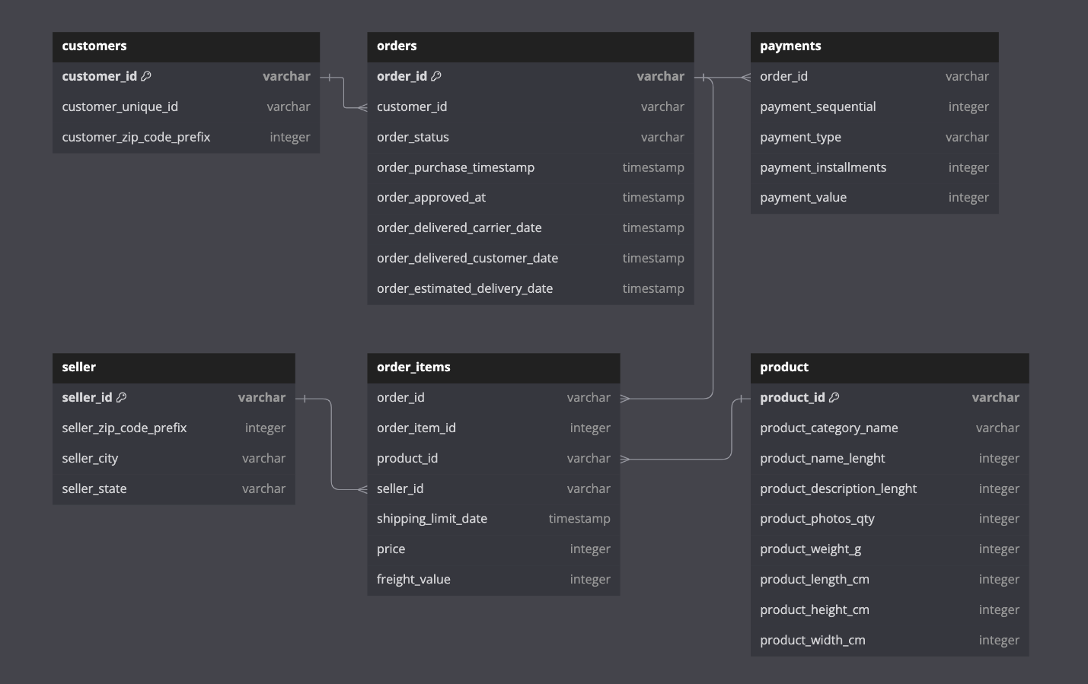
Here is the schema of the provided data, including relationships and primary keys for each table. Make sure to review the one-to-one and one-to-many relationships for a better understanding and analysis.
Guide for Data Preparation and Analysis
- Download the Data:
  - Download the data from each sheet of the provided schema in Excel format.
  - Save each sheet separately as a CSV file. For example, save the "Customers" sheet as customers.csv, the "Orders" sheet as orders.csv, and so on.
- Prepare PostgreSQL Environment:
  - Open pgAdmin and connect to your PostgreSQL server.
  - Create a new database named amazon_analysis to store all your data.
  - In the amazon_analysis database, create a new schema named amazon_brazil to organize the tables.
- Create Tables in PostgreSQL:
  - Use the CREATE TABLE SQL command to define the schema for each table. Make sure to include all necessary columns and set primary keys based on the schema provided.
- Import Data into PostgreSQL:
  - Open the Table Import/Export Tool:
    - In pgAdmin, navigate to the amazon_brazil schema, right-click on the table you want to import data into (e.g., customers), and select "Import/Export."
  - Configure the Import:
    - In the Import/Export dialog:
      - Set the "Format" to CSV.
      - In the "Filename" field, browse to the location where you saved the corresponding CSV file (e.g., customers.csv).
      - Select the "Delimiter" as , (comma).
      - Check the "Header" option if your CSV file contains column headers.
    - Click "OK" to start the import process.
  - Repeat for All Tables: Repeat the above steps to import data into all the required tables (e.g., orders, order_items, products, etc.).
The whole analysis is divided into 3 parts and it covers different topics in each analysis starting from basic SQL to Joins to Window and CTE functions.

Analysis - I
- To simplify its financial reports, Amazon India needs to standardize payment values. Round the average payment values to integer (no decimal) for each payment type and display the results sorted in ascending order.
  - Output: payment_type, rounded_avg_payment
- To refine its payment strategy, Amazon India wants to know the distribution of orders by payment type. Calculate the percentage of total orders for each payment type, rounded to one decimal place, and display them in descending order
  - Output: payment_type, percentage_orders
- Amazon India seeks to create targeted promotions for products within specific price ranges. Identify all products priced between 100 and 500 BRL that contain the word 'Smart' in their name. Display these products, sorted by price in descending order.
  - Output: product_id, price
- To identify seasonal sales patterns, Amazon India needs to focus on the most successful months. Determine the top 3 months with the highest total sales value, rounded to the nearest integer.
  - Output: month, total_sales
- Amazon India is interested in product categories with significant price variations. Find categories where the difference between the maximum and minimum product prices is greater than 500 BRL.
  - Output: product_category_name, price_difference
- To enhance the customer experience, Amazon India wants to find which payment types have the most consistent transaction amounts. Identify the payment types with the least variance in transaction amounts, sorting by the smallest standard deviation first.
  - Output: payment_type, std_deviation
- Amazon India wants to identify products that may have incomplete name in order to fix it from their end. Retrieve the list of products where the product category name is missing or contains only a single character.
  - Output: product_id, product_category_name

Analysis - II
- Amazon India wants to understand which payment types are most popular across different order value segments (e.g., low, medium, high). Segment order values into three ranges: orders less than 200 BRL, between 200 and 1000 BRL, and over 1000 BRL. Calculate the count of each payment type within these ranges and display the results in descending order of count
  - Output: order_value_segment, payment_type, count
- Amazon India wants to analyse the price range and average price for each product category. Calculate the minimum, maximum, and average price for each category, and list them in descending order by the average price.
  - Output: product_category_name, min_price, max_price, avg_price
- Amazon India wants to identify the customers who have placed multiple orders over time. Find all customers with more than one order, and display their customer unique IDs along with the total number of orders they have placed.
  - Output: customer_unique_id, total_orders
- Amazon India wants to categorize customers into different types ('New – order qty. = 1' ; 'Returning' –order qty. 2 to 4; 'Loyal' – order qty. >4) based on their purchase history. Use a temporary table to define these categories and join it with the customers table to update and display the customer types.
  - Output: customer_unique_id, customer_type
- Amazon India wants to know which product categories generate the most revenue. Use joins between the tables to calculate the total revenue for each product category. Display the top 5 categories.
  - Output: product_category_name, total_revenue

Analysis - III
- The marketing team wants to compare the total sales between different seasons. Use a subquery to calculate total sales for each season (Spring, Summer, Autumn, Winter) based on order purchase dates, and display the results. Spring is in the months of March, April and May. Summer is from June to August and Autumn is between September and November and rest months are Winter.
  - Output: season, total_sales
- The inventory team is interested in identifying products that have sales volumes above the overall average. Write a query that uses a subquery to filter products with a total quantity sold above the average quantity.
  - Output: product_id, total_quantity_sold
- To understand seasonal sales patterns, the finance team is analysing the monthly revenue trends over the past year (year 2018). Run a query to calculate total revenue generated each month and identify periods of peak and low sales. Export the data to Excel and create a graph to visually represent revenue changes across the months.
  - Output: month, total_revenue
- A loyalty program is being designed for Amazon India. Create a segmentation based on purchase frequency: ‘Occasional’ for customers with 1-2 orders, ‘Regular’ for 3-5 orders, and ‘Loyal’ for more than 5 orders. Use a CTE to classify customers and their count and generate a chart in Excel to show the proportion of each segment.
  - Output: customer_type, count
- Amazon wants to identify high-value customers to target for an exclusive rewards program. You are required to rank customers based on their average order value (avg_order_value) to find the top 20 customers.
  - Output: customer_id, avg_order_value, and customer_rank
- Amazon wants to analyze sales growth trends for its key products over their lifecycle. Calculate monthly cumulative sales for each product from the date of its first sale. Use a recursive CTE to compute the cumulative sales (total_sales) for each product month by month.
  - Output: product_id, sale_month, and total_sales
- To understand how different payment methods affect monthly sales growth, Amazon wants to compute the total sales for each payment method and calculate the month-over-month growth rate for the past year (year 2018). Write query to first calculate total monthly sales for each payment method, then compute the percentage change from the previous month.
  - Output: payment_type, sale_month, monthly_total, monthly_change.

